Faster healing of bone injuries
For many patients, losing several centimetres of bone from the lower leg following a serious injury or tumour extraction is only the beginning of a long-lasting ordeal. However, autologous stem cells have been found to accelerate and boost the healing process.

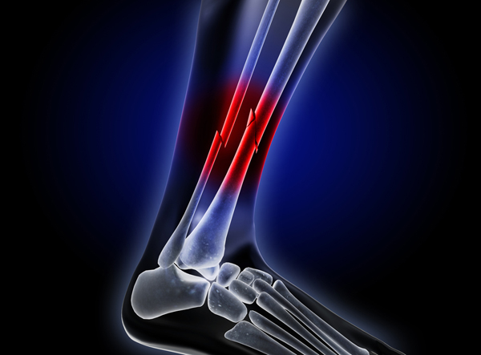

Surgeons at the RUB clinic Bergmannsheil have achieved promising results: without stem cells, it takes 49 days on average for one centimetre of bone to regrow; with stem cells, that period has been reduced to 37 days.
In the past, large bone defects inevitably led to an amputation. Today, the arm or leg is stabilised in an external support, and a transport wire is pulled through the marrow of the intact part of the injured bone. Once the soft tissue surrounding the injury is healed, the surgeons cut the healthy part of the bone into two. The transport wire is affixed to the winches of a ring fixator that is attached around the leg. Using a sophisticated cable-pull system, the previously detached part of the bone is slowly pulled either downwards or upwards along the gap in the bone until it arrives and docks at the other end. During the pulling stage, the periosteum of the bone that had been pulled apart had been continuously stretched. Thus, a periosteum tube is created in the gap behind the relocated portion of the bone. Inside that tube, the new bone can regenerate. This process, however, is extremely tedious and the treatment fails in 20% of cases.
Processing autologous stem cells in the operating theatre
Surgeons at the RUB clinic attempted to optimise the healing process, by applying autologous stem cell therapy (in which cells are removed, stored, and later given back to the same person). Depending on the requirements, stem cells can evolve into different types of tissue cells, including so-called osteoblasts – cells that are responsible for bone formation. Adult stem cells needed in this process can be found in the bone marrow of adults. "We harvest them by inserting a hollow needle into the iliac crest," said Dr Dominik Seybold.

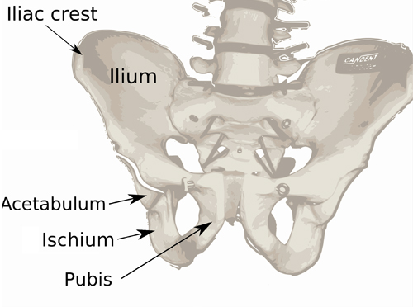

The stem cells are prepared for application directly on location. Under x-ray control, surgeons inject six to eight millilitres of concentrated fluid into the centre of the periosteum tube. X-ray controls are routinely performed to monitor the recovery progress. To date, the physicians have applied this therapy in only 20 cases, but results so far are encouraging. Whilst the bone regeneration process without stem cells used to take 49 days per cubic centimetre, it has been reduced to 37 days on average thanks to this new method. So far, RUB scientists have been treating bone defects with an average length of 8cm (3.1"). Consequently, the patients have recovered, on average, three months sooner.
In the future, could healing times be accelerated even further? Certainly it seems possible, through nanotechnology and other means. The renowned futurist Ray Kurzweil envisions a time – perhaps within a few decades – when billions of microscopic machines patrol our blood vessels. These could be wirelessly controlled by an external computer and directed precisely to where they are needed, repairing injuries and other damage with astonishing speed. A similar idea has been explored in Robert Reed's Marrow, a sci-fi novel in which injuries can be healed almost instantly.

